**55. _helpers.tpl again**

--- we will revisit the helpers.tpl file. **.tpl** stands for template because this file hosts several templates that can be used across our template files.

--- tree

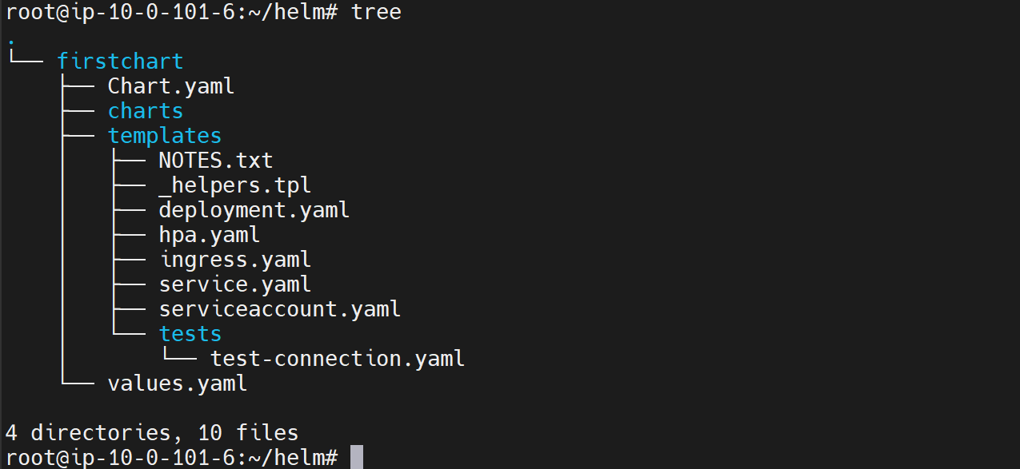

--- **Cat _helpers.tpl**

{{/*

Expand the name of the chart.

*/}}

{{- define "firstchart.name" -}}

{{- default .Chart.Name .Values.nameOverride | trunc 63 | trimSuffix "-" }}

{{- end }}

{{/*

Create a default fully qualified app name.

We truncate at 63 chars because some Kubernetes name fields are limited to this (by the DNS naming spec).

If release name contains chart name it will be used as a full name.

*/}}

{{- define "firstchart.fullname" -}}

{{- if .Values.fullnameOverride }}

{{- .Values.fullnameOverride | trunc 63 | trimSuffix "-" }}

{{- else }}

{{- $name := default .Chart.Name .Values.nameOverride }}

{{- if contains $name .Release.Name }}

{{- .Release.Name | trunc 63 | trimSuffix "-" }}

{{- else }}

{{- printf "%s-%s" .Release.Name $name | trunc 63 | trimSuffix "-" }}

{{- end }}

{{- end }}

{{- end }}

{{/*

Create chart name and version as used by the chart label.

*/}}

{{- define "firstchart.chart" -}}

{{- printf "%s-%s" .Chart.Name .Chart.Version | replace "+" "_" | trunc 63 | trimSuffix "-" }}

{{- end }}

{{/*

Common labels

*/}}

{{- define "firstchart.labels" -}}

helm.sh/chart: {{ include "firstchart.chart" . }}

{{ include "firstchart.selectorLabels" . }}

{{- if .Chart.AppVersion }}

app.kubernetes.io/version: {{ .Chart.AppVersion | quote }}

{{- end }}

app.kubernetes.io/managed-by: {{ .Release.Service }}

{{- end }}

{{/*

Selector labels

*/}}

{{- define "firstchart.selectorLabels" -}}

app.kubernetes.io/name: {{ include "firstchart.name" . }}

app.kubernetes.io/instance: {{ .Release.Name }}

{{- end }}

{{/*

Create the name of the service account to use

*/}}

{{- define "firstchart.serviceAccountName" -}}

{{- if .Values.serviceAccount.create }}

{{- default (include "firstchart.fullname" .) .Values.serviceAccount.name }}

{{- else }}

{{- default "default" .Values.serviceAccount.name }}

{{- end }}

{{- end }}

**Comment in _helpers.tpl**

{{/*

Expand the name of the chart.

*/}}

--- **note** – this is how you can comment a

**Define a function**

{{- define "firstchart.name" -}}

{{- default .Chart.Name .Values.nameOverride | trunc 63 | trimSuffix "-" }}

{{- end }}

--- define "firstchart.name" - First chart is a unique namespace. This is the actual name of the template.

--- firstchart is unique namespace. Why do we need a namespace? Because so far, the charts we have been creating or application charts to deploy our applications to Kubernetes but Helm also supports library charts.

--- Those charts are not specific to any application. We can reuse those charts across the charts for our applications.

--- In that case, we do not want multiple people naming these templates, giving their templates the same name and then we having problems to use those templates in our application.

--- For example, if a guy has a template called **loadondeployment**. This is a template somebody has created and they have given it out as a library chart library. Now we start using this template across our template files and another library also has used the same template name, and we are using both the libraries now in our template files, we do not want to have issues. With using the same name, that is way the concept of namespace exists.

--- **name** – the name is taken form the **chart.yml**

**Include function**

{{- define "firstchart.selectorLabels" -}}

app.kubernetes.io/name: {{ include "firstchart.name" . }}

app.kubernetes.io/instance: {{ .Release.Name }}

{{- end }}

--- **firstchart.name** – in the **firstchart.selectorLabels** template, we are using firstchart.name. because of include function.

--- **note** – we call above is template, we can use the above template across the different template files.

--- **what is the difference between include and template…?**

If you use include then you can use piping. Something is not possible with template.